Software Requirements Specification

for

UrWallet Web-Application

Version 1.0

Prepared by

**Farrell Anandra Sadtyanto – 2201747622**

**Shonny Sholahudin – 2201823416**

**Aldandi Fitra Ramadhan – 2201830226**

**Gregorius Aldo Primantono – 2201846395**

Bina Nusantara University

2020

Table of Contents

Table of Contents ii

Revision History ii

1. Introduction 1

1.1 Purpose 1

1.2 Document Conventions 1

1.3 Intended Audience and Reading Suggestions 1

1.4 Product Scope 1

1.5 References 1

2. Overall Description 2

2.1 Product Perspective 2

2.2 Product Functions 2

2.3 User Classes and Characteristics 2

2.4 Non-Functional Requirements 2

3. Requirements Specification 3

3.1 External Interface Requirements 3

3.2 Functional Requirements 3

3.3 Detailed Non-Functional Requirements 3

Revision History

|  |  |  |  |
| --- | --- | --- | --- |
| **Name** | **Date** | **Reason For Changes** | **Version** |
|  |  |  |  |
|  |  |  |  |

# Introduction

## Purpose

The purpose of UrWallet Web-Applications is to make people to calculate income and expense easier.

## Document Conventions

We are using Times with font size 14 for the contents heading and Arial with font size 11 for the contents. For the header, we use Arial with font size 32. We use bold font for every contents heading.

## Intended Audience and Reading Suggestions

This Project help customers who have problems in managing finances to be able to choose how much to spend and their priorities. Also, This project is restricted within the university premises.

## Product Scope

People who have financial problems, especially people who are middle to lower income people with many needs and desires but still cannot save money even are in debt.

## References

* IEEE Software Engineering Standards Committee, “IEEE Std 830-1998, IEEE Recommended Practice for Software Requirements Specifications”, October 20, 1998.
* <http://web.itu.edu.tr/~tanriverdin/proje/SRSSample.doc>
* <http://www.cse.msu.edu/~chengb/RE-491/Papers/SRSExample-webapp.doc>

# Overall Description

## Product Perspective

UrWallet System

## Product Functions

***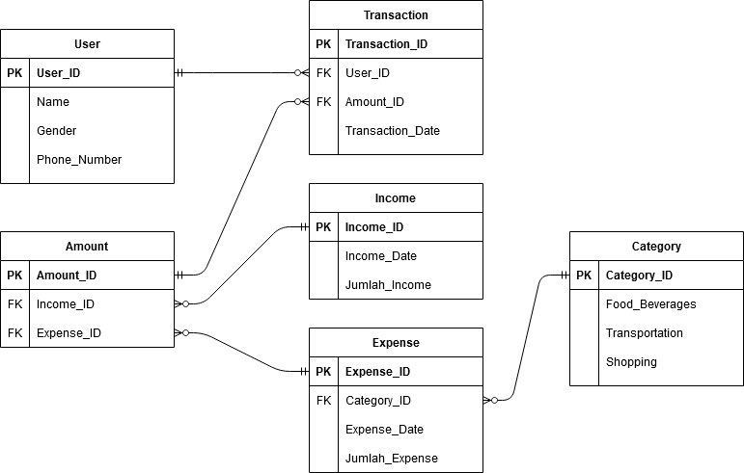*Entity Relationship Model**

**2.2.1 User Use Case**

**Use Case : Sign Up**

**Description :**

The user choose sign up on main menu.

**Initial step-by-step description:**

For this use case, the user must be connected to the internet and connected to UrWallet Web Server.

1. The user connects to UrWallet Web Sever
2. The user choose sign up menu
3. The user fill the personal information such as name, gender, and phone number.

**Use Case : Sign In**

**Description :**

The user choose sign in on main menu.

**Initial step-by-step description:**

For this use case, the user must be connected to the internet and connected to UrWallet Web Server.

1. The user connects to UrWallet Web Sever
2. The user choose sign in menu
3. The user input phone number and password.
4. The system will sign in the user if the user input phone number and password correctly.
5. The system will not sign in the user if there any mistakes on phone number or password.

**Use Case : Transaction**

**Description :**

The user choose transaction. There are incomes and expenses on transaction menu.

**Initial step-by-step description:**

For this use case, the user must be connected to the internet and connected to UrWallet Web Server.

1. The user connects to UrWallet Web Server.
2. The user selects transaction button.

**Use Case : Incomes**

**Description :**

The user choose incomes menu after transaction menu.

**Initial step-by-step description:**

For this use case, the user must be connected to the internet and connected to UrWallet Web Server.

1. The user connects to UrWallet Web Server.
2. The user selects incomes button.
3. The user enters the income amount.

**Use Case : Expenses**

**Description :**

The user choose expenses menu after transaction menu.

**Initial step-by-step description:**

For this use case, the user must be connected to the internet and connected to UrWallet Web Server.

1. The user connects to UrWallet Web Server.
2. The user selects expenses button.
3. The user enters the expenses amount.

**Use Case : User Management**

**Description :**

The Admin choose user management. There are create account and delete account on user management menu.

**Initial step-by-step description:**

For this use case, the user must be connected to the internet and connected to UrWallet Web Server.

1. The user connects to UrWallet Web Server.
2. The admin selects the user management button.

**2.2.2 Admin Use Case**

**Use Case : Delete account**

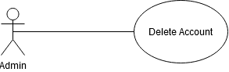

**Description :**

The Admin will delete user account if the user abuse UrWallet.

**Initial step-by-step description:**

For this use case, the user must be connected to the internet and connected to UrWallet Web Server.

1. The admin selects the delete account button.
2. The admin will email the user for abusing the UrWallet Web-Apps.

## User Classes and Characteristics

There will be two user classes, User and Admin.

User:

* User able to input incomes.
* User able to input expenses.
* User able to check transaction history.

Admin:

* Admin able to delete users account.
* Admin able to view users account.
* Admin able to view transaction of users.

## Non-Functional Requirements

The website must be connected to the internet and must be compatible with Google Chrome and Firefox.

# Requirements Specification

## External Interface Specification

None

## Functional Requirements

## 3.2.1 Sign Up

|  |  |
| --- | --- |
| Use Case Name | Sign Up |
| XRef | - |
| Trigger | The user press sign up button on the main menu. |
| Precodition | 1. The user must be on the UrWallet main menu. 2. The user do not have UrWallet account. |
| Basic Paths | 1. The user inputs their name, gender, and phone number. 2. The user press sign up button. 3. The user will be logged in. |
| Alternative Paths | - |
| Postcondition | The user’s account is created. |
| Exception Paths | Sign up will fail if the user phone number is already registered. |
| Other | None |

## 3.2.2 Sign In

|  |  |
| --- | --- |
| Use Case Name | Sign In |
| XRef | - |
| Trigger | The user press sign in button on the main menu. |
| Precodition | 1. The user must be on the UrWallet main menu. 2. The user must have an UrWallet account. |
| Basic Paths | 1. The user inputs their phone number and password 2. The user press sign in button. 3. The user will be logged in. |
| Alternative Paths | - |
| Postcondition | The user is logged in. |
| Exception Paths | Sign in will fail if the did not input phone number and password correctly |
| Other | None |

## 3.2.3 Transaction

|  |  |
| --- | --- |
| Use Case Name | Transaction |
| XRef | - |
| Trigger | The user press transaction button on the transaction page. |
| Precodition | 1. The user must be logged in into UrWallet 2. The user must have an UrWallet account. |
| Basic Paths | 1. The user press transaction button 2. There will be 2 option, incomes and expenses. 3. The user press incomes or expenses button. 4. The user fill the amount of incomes or expenses. 5. If the user press the expenses button, there will be 3 categories of expenses, such as Food and Beverage, Transportation and Shopping. |
| Alternative Paths | - |
| Postcondition | The amount of incomes or expenses will be noted in UrWallet Web Apps |
| Exception Paths | The user can edit the amount of incomes or expenses if there is a mistakes. |
| Other | None |

## Detailed Non-Functional Requirements

|  |  |  |  |  |
| --- | --- | --- | --- | --- |
| Attributes | Description | Data Type & Length | NULLS | Multi-Valued |
| User_ID  Name  Gender  Phone_Number | ID dari user UrWallet  Nama dari user UrWallet  Jenis kelamin dari user UrWallet  Nomor telefon dari user UrWallet | Int(7)  Varchar(30)  Char(L or P)  Varchar(15) | NO  NO  NO  NO | NO  NO  NO  NO |
| Transaction_ID  User_ID  Amount_ID  Transaction_Date | ID dari transaksi  ID dari user UrWallet  ID dari jenis transaksi  Tanggal transaksi | Varchar(7)  Varchar(7)  Varchar(7)  Date | NO  NO  NO  NO | NO  NO  NO  NO |
| Amount_ID  Income_ID  Expense_ID | ID dari jenis transaksi  ID dari pemasukan  ID dari pengeluaran | Varchar(7)  Varchar(7)  Varchar(7) | NO  NO  NO | NO  NO  NO |
| Income_ID  Income_Date  Jumlah_Income | ID dari pemasukan  Tanggal dari pemasukan  Jumlah uang pemasukan | Varchar(7)  Date  Varchar(12) | NO  NO  NO | NO  NO  NO |
| Expense_ID  Category_ID  Expense_Date  Jumlah_Expense | ID dari pengeluaran  Kategori pengeluaran  Tanggal pengeluaran  Jumlah uang pengeluaran | Varchar(7)  Varchar(7)  Date  Varchar(12) | NO  NO  NO  NO | NO  NO  NO  NO |
| Category_ID  Food_Beverage  Transportation  Shopping | ID dari kategori pengeluaran  Kategori makanan dan minuman  Kategori transportasi  Kategori belanja | Varchar(7)  Varchar(20)  Varchar(20)  Varchar(20) | NO  NO  NO  NO | NO  NO  NO  NO |
| Admin_ID  Name  Gender  Phone_Number | ID dari admin UrWallet  Nama dari admin UrWallet  Jenis kelamin dari admin UrWallet  Nomor telefon dari admin UrWallet | Int(7)  Varchar(30)  Char(L or P)  Varchar(15) | NO  NO  NO  NO | NO  NO  NO  NO |